A

PROJECT REPORT

ON

**VR Horror Game**

Submitted in partial fulfilment of the requirements of the degree of

**Bachelor of Engineering**

**In**

**Information Technology**

by

Ritvik Babre 05

Hitesh Behera 06

Shruti Sabbani 50

Swapnil Yadav 67

Supervisor:

**Prof. Punam Bagul**



**Department of Information Technology**

K.C. College of Engineering and Management Studies and

Research, Thane (E)

University of Mumbai

2023-24

**CERTIFICATE**

This is to certify that the project entitled **“VR Horror Game”** is a bonafide work of “**Ritvik Babre (05), Hitesh Behera (06), Shruti Sabbani (50), Swapnil Yadav (67)” submitted** to the University of Mumbai in partial fulfillment of the requirement for the award of the degree of **“Bachelor of Engineering”** in

**“Information Technology”**.

Name and sign Name and sign

Supervisor/Guide Co-Supervisor/Guide



Prof. Amarja Adgaonkar

Head of Department Principal

**Project Report Approval for B.E.**

This project report entitled **“VR Horror Game”** by **Ritvik Babre (05), Hitesh Behera (06), Shruti Sabbani (50), Swapnil Yadav (67)**

is approved for the degree of Bachelor of Engineering in **Information Technology.**

Examiners

1.---------------------------------------------

2.---------------------------------------------

Date:

Place: Thane

**DECLARATION**

We declare that this written submission represents our ideas in our own words and where others' ideas or words have been included, we have adequately cited and referenced the original sources. We also declare that we have adhered to all principles of academic honesty and integrity and have not misrepresented or fabricated or falsified any idea/data/fact/source in our submission. We understand that any violation of the above will be cause for disciplinary action by the Institute and can also evoke penal action from the sources which have thus not been properly cited or from whom proper permission has not been taken when needed.

(Signature)

1.Ritvik Babre (05)

1. Hitesh Behera (06)
2. Shruti Sabbani (50)
3. Swapnil Yadav (67)

Date:

**ACKNOWLEDGEMENT**

We would like to express special thanks of gratitude to our guide **Prof. Punam Bagul** as well as our Project Coordinator **Asst.** **Prof. Aarti Abhyankar** who gave us the golden opportunity to do this wonderful project on the topic of **VR Horror Game**, which also helped us in doing a lot of research and we came to know about so many new things. We are very grateful to our Head of the Department **Prof. Amarja Adgaonkar** for extending her help directly and indirectly through various channels in our project work**.** We would also like to thank Principal **Dr. Vilas Nitnaware** for providing us the opportunity to implement our project. We are really thankful to them. Finally, we would also like to thank our parents and friends who helped us a lot in finalizing this project within the limited time frame.

Thanking You.

**TABLE OF CONTENT**

**Sr.No. Topic Page No.**

**Certificate i**

**Approval Sheet ii**

**Declaration iii**

**Acknowledgement iv**

**List of Figures vii**

**List of Table ix**

**Abstract x**

1. **Introduction……………………………………………………………………… 1**
2. **Literature Survey………………………………………………………………….2**

**3.Proposed Work**

3.1 Requirement Analysis ……………………………………………….5

3.1.1 Scope ………………………………………………. 5

3.1.2 Feasibility Study ………………………………………5

3.1.3 Hardware & Software Requirement …………………………7

3.2 Problem Statement ………………………………………………………8

3.3 Project Design……………………………………………………………8

3.4 Methodology………………………………………………………………10

3.4.1 Implementation Plan …………………………………………………….13

1. **Test Cases** **…………………………………………………………………………21**
2. **Results and Discussion ………………………………………………………22**

**Conclusion and Future Scope………………………………………………….23**

**References……………………………………………………………………………24**

**LIST OF FIGURES**

|  |  |  |
| --- | --- | --- |
| **Figure No** | **Name of Figure** | **Page no** |
| 3.3.1 | DFD level 0 | 8 |
| 3.3.2 | Class Diagram | 9 |
| 3.3.3 | Use Case Diagram | 9 |
| 3.3.4 | Basic Flow of Game | 10 |
| 3.3.5 | Architecture of the Game | 10 |
| 3.3.6 | Flowchart | 13 |
| 3.5.1 | Game Manager Flowchart | 15 |
| 5.1 | Gyroscopic Head Tracking Flowchart | 16 |
| 5.3 | Mechanism to Pick Up Items | 17 |
| 5.4 | Item Spawner Flowchart | 18 |
| 5.5 | Enemy Movement Flowchart | 19 |
| 5.6 | Enemy collider Implementation | 20 |
| 5.7 | Game Map | 21 |

**LIST OF TABLES**

|  |  |  |
| --- | --- | --- |
| **Table No.** | **Name of Table** | **Page No** |
| 4.1 | Test Cases | 21 |

###### ABSTRACT

In this report, we proposed an analysis framework that examines participants' immersive experience processes from three dimensions: (1) the state of enjoyment, (2) the transformation of the awareness of time, and (3) a sense of spatial integration. We found that the balance of skills and challenges is threshold factor affecting participants’ overall enjoyment state and experience of transforming the time awareness during a VR gaming process. With cutting-edge VR technology, you will be transported to a place where your every sense is assaulted by the unknown, and your survival instincts are pushed to the limit. Confront your deepest fears, solve intricate puzzles, and face grotesque monstrosities as you journey deeper into the darkness.

To promote virtual reality (VR) in India, a multi-faceted approach is essential. This involves raising awareness through targeted campaigns, fostering collaboration between government, industry, and educational institutions, and providing support to startups and developers. Encouraging the creation of high-quality VR content, integrating VR into education and training programs, and investing in infrastructure are also crucial. By establishing a conducive ecosystem, India can harness the potential of VR to drive innovation, economic growth, and social development, while positioning itself as a leader in immersive technology on the global stage.

## **1. Introduction**

## Virtual reality (VR) horror games offer an unparalleled level of immersion by leveraging first-person perspective, realistic graphics, and interactive gameplay. Players experience the game world through the eyes of the protagonist, enhancing the feeling of presence and intensifying the horror experience. Detailed environments, coupled with atmospheric lighting, create a sense of dread, while interactivity allows players to manipulate objects and solve puzzles. Jump scares are effectively utilized to startle players, taking advantage of the heightened sense of immersion in VR. Compelling narratives further engage players, drawing them deeper into the terrifying world of VR horror gaming.

## Virtual reality (VR) is of paramount importance due to its ability to offer immersive and interactive experiences that transcend traditional boundaries. It holds significant potential across various domains, including education, training, healthcare, entertainment, and beyond. VR enables users to explore virtual environments, practice real-life scenarios, and engage with content in ways that are not possible through conventional mediums. By providing realistic simulations, VR enhances learning outcomes, improves skill retention, and fosters creativity and innovation. Moreover, VR has therapeutic applications, aiding in rehabilitation, pain management, and mental health treatments. In entertainment, VR offers unparalleled immersion, allowing users to immerse themselves in virtual worlds and experiences. Overall, the importance of VR lies in its capacity to revolutionize how we learn, work, play, and connect with others, shaping the future of technology and human interaction.

## Horror genre consistently rank highly across demographics and gaming platforms, showcasing their widespread appeal and engagement. Horror games excel in delivering an immersive experience that truly transports users to another world, creating a sense of fear and suspense that showcases VR's capabilities effectively. The use of spatial audio further enhances this sense of immersion, drawing players deeper into the game environment. In India, where horror stories and supernatural themes hold cultural significance, VR horror games have the potential to resonate strongly with audiences across all demographics who are enthusiastic consumers of horror content. By leveraging the universal appeal and emotional impact of horror games, VR technology can be effectively promoted and embraced as a powerful medium for immersive experiences and storytelling in the future.

## Using VR horror games to promote VR in India can be a strategic approach due to several factors. Firstly, horror games International Conference on Advance Technology and Management in VR offer an unparalleled level of immersion and engagement, evoking strong emotional responses from players. This heightened sense of fear and suspense effectively showcases the capabilities of VR technology, allowing users to experience a thrilling and realistic environment unlike any other medium. Additionally, horror games have a universal appeal and a strong following in Indian culture, tapping into the country's fascination with ghost stories, folklore, and supernatural themes. By capitalizing on this cultural interest, VR horror games can attract attention and generate excitement among Indian audiences, particularly younger demographics who are avid consumers of horror content. Moreover, the use of VR horror games provides a unique selling point for VR technology, offering experiences that are exclusive to the platform and differentiating it from traditional forms of entertainment. Ultimately, by leveraging the immersive and emotional power of horror games in VR, promoters can effectively showcase the potential of VR technology and drive adoption and interest among Indian consumers.

## **2. Literature Survey**

## 1. Konstantinos Ntokos's research, titled "Level of Fear," introduces a compelling tool for horror game design that focuses on analyzing and categorizing fear within the gaming experience. This tool is instrumental in assisting developers to calibrate the difficulty and scariness of their games. It achieves this by plotting the intensity levels of fear throughout the game, helping to maintain a balance of fear and relief. Furthermore, Ntokos's approach includes classifying ingame elements based on their respective "level of fear," ensuring that developers have a systematic way of creating a terrifying and immersive atmosphere. Overall, this research equips game developers with an effective and practical tool to enhance player immersion and fear in the world of horror games.

## 2. Mikolaj Dymek's research on horror game design explores the factors that instill fear in players. Dymek emphasizes the importance of dark environments and the role of environmental design, sound design, lighting, and gameplay narrative in creating fear. The inclusion of auditory hallucinations, such as human screams, is noted as a potent tool to improve gameplay experience, enhance player immersion, and leave a lasting impression, differentiating the game from others in the genre. Dymek also highlights that successful horror game design combines well with level design and navigation patterns, offering a comprehensive approach to scare players effectively, making it an essential consideration in horror game development.

## 3. Ziwen Zhang's research, "Analysis of the Design Aesthetics and Player Emotions of Horror Games," employs a comprehensive approach, combining both qualitative and quantitative research methods alongside biometric measures. By doing so, Zhang enhances the validity and reliability of the study, ensuring accuracy and robust results. The use of triangulation, which involves cross-validating results, minimizes biased interpretations. The study reveals that horror games evoke emotions such as fear and excitement, and it recognizes that the experience is influenced by the player's level of experience. Moreover, the research highlights the pivotal role of factors like a sense of achievement, excitement, and puzzlesolving in determining players' satisfaction with the game, offering valuable insights for both game designers and researchers in the horror gaming domain.

## 4. Connor Bulmer's "VHS Horror - Game Design Document" presents a vision for a one-of-akind survival horror game that offers an engaging and immersive experience. This project targets a specific audience while keeping development costs reasonable and sales targets achievable. The game's thematic focus revolves around elements of discovery, fear, triumph, and minimalism, intricately woven into its gameplay mechanics. Efficient level design and a captivating in-game economy contribute to player engagement, promising an immersive and thrilling experience for its intended audience. In summary, International Conference on Advance Technology and Management "VHS Horror" is designed to be a unique, cost-effective, and immersive horror gaming experience with a strong thematic foundation.

## 5. The research paper titled "Movement visualizer for networked virtual reality platforms," presented at the 2018 IEEE Conference on Virtual Reality and 3D User Interfaces, introduces a system designed to enhance coordination and collaboration in networked virtual reality (VR) environments. Authored by Omar Shaikh, Yilu Sun, and Andrea Stevenson Won, the paper outlines the development and implementation of a movement visualizer system that provides real-time feedback on the movements and actions of multiple users within a networked VR space. By capturing and processing movement data from VR users and generating visualizations such as avatar representations, trails, and heatmaps, the system aims to improve user awareness and interaction in multiplayer VR experiences. Through evaluation and experimentation, the paper demonstrates the effectiveness of the movement visualizer in enhancing user collaboration and overall VR experience.

## 6. The research paper titled "So scary, yet so fun: The role of self-efficacy in enjoyment of a virtual reality horror game," published in New Media & Society in 2018, explores the relationship between self-efficacy and enjoyment in the context of playing virtual reality (VR) horror games. Authored by JihHsuan Tammy Lin, Dai-Yun Wu, and Chen-Chao Tao, the study investigates how individuals' belief in their ability to cope with fear influences their enjoyment of VR horror games. Through surveys and interviews with participants, the paper examines factors such as presence, immersion, and perceived control over the game environment. The findings suggest that higher levels of self-efficacy are associated with increased enjoyment of VR horror games, highlighting the importance of users' confidence in managing fear-related experiences for their overall gaming experience.

## 7. The research paper titled "Virtual Reality Horror Games and Fear in Gaming," published in the Oxford Research Encyclopedia of Communication in 2023, delves into the intricate relationship between virtual reality (VR) horror games and the experience of fear among gamers. Authored by Tammy Jin-Hsuan Lin, the paper explores how VR technology has revolutionized horror gaming by immersing players in terrifying environments and evoking intense emotional responses. Through an analysis of gameplay mechanics, narrative techniques, and psychological theories, the paper examines how VR horror games leverage immersion, presence, and interactivity to induce fear and suspense in players. By understanding the psychological mechanisms behind fear in gaming, the paper provides insights into the design and development of more immersive and impactful VR horror experiences.

## 8. The research paper titled "Research on the Application of VR in Games," published in Highlights in Science, Engineering, and Technology in 2023, explores the utilization of virtual reality (VR) technology within the gaming industry. Authored by Shijie Bian, the paper investigates the various ways in which VR enhances gaming experiences, including improved immersion, interactivity, and realism. Through an analysis of existing VR gaming applications and technological advancements, the paper highlights the potential of VR to revolutionize gaming by providing players with more immersive and engaging experiences. Additionally, it discusses the challenges and opportunities associated with the adoption of VR in game development, paving the way for future research and innovation in this rapidly evolving field.

## 9. The research paper titled "Research on the Progress of VR in Game," published in Highlights in Science, Engineering, and Technology in 2023, provides an overview of the advancements and developments in virtual reality (VR) technology within the gaming industry. Authored by Ruiqi Zhang, the paper examines the progress made in integrating VR into various aspects of game design, including graphics, user interfaces, and gameplay mechanics. By analyzing recent trends, innovations, and challenges in VR gaming, the paper offers insights into the evolving landscape of immersive gaming experiences. Furthermore, it discusses the potential impact of VR on the future of gaming and the opportunities it presents for enhancing player engagement and interaction.

## **3. Proposed work**

## **3.1. Requirement Analysis**

3.1.1 Scope

The scope for an immersive FPV virtual reality horror game is substantial, offering a thrilling and deeply immersive experience to players. With the ever-evolving technology in the virtual reality sector, developers have the opportunity to craft terrifying and atmospheric worlds that blur the line between reality and the virtual realm. Creating an engaging narrative, realistic graphics, and a spine-chilling audio experience is essential to captivate the player's senses. Integrating VR interactions, environmental hazards, and exploration adds depth to the gameplay. Multiplayer modes can enhance the social aspect of the horror experience. However, success requires careful optimization for different VR platforms and a focus on player comfort to minimize motion sickness. The horror genre's strong appeal to a dedicated fan base, coupled with effective marketing and post-launch support, presents a promising market for developers who can master the intricacies of creating a truly immersive and terrifying virtual reality horror game.

###### 3.1.2 Feasibility Study

A feasibility study for an immersive first-person view (FPV) virtual reality horror game is a

critical step in determining whether the project is viable and worth pursuing. This study

involves assessing various aspects, including technical, financial, and market considerations.

Here's a framework for conducting a feasibility study:

**Market Analysis:**

Identify the target audience for the game, such as VR enthusiasts, horror game fans, or a broader

consumer base. Analyze the current VR market, including trends, competition, and the potential

for growth in the horror gaming niche. Conduct surveys or focus groups to gauge interest and

gather feedback on potential features and themes.

**Technical Feasibility:**

Assess the technical requirements and challenges of developing an immersive VR horror game,

such as hardware compatibility and graphical demands. Consider the available development

tools, software, and resources needed for the project. Evaluate the team's expertise and

capabilities in VR development.

**Financial Feasibility:**

Create a detailed budget that includes development costs, marketing expenses, and post-launch

support. Estimate the revenue potential, taking into account potential pricing models.

**Legal and Ethical Considerations:**

Investigate potential legal issues related to content, intellectual property rights, and compliance

with regional regulations. Assess the ethical considerations, particularly concerning content

that may be distressing or frightening to players.

**Resource Assessment:**

Identify the human resources required, such as game designers, programmers, 3D artists, and

sound engineers. Evaluate the availability of these resources and assess whether additional

talent needs to be hired or outsourced.

**Technology Assessment:**

Consider the VR hardware platforms that the game will be developed for (e.g., PC VR, console

VR, or standalone VR headsets). Ensure the chosen technology aligns with the target audience

and market trends.

**Timeframe:**

Develop a project timeline that outlines key milestones, including development, testing, and

launch dates. A well-conducted feasibility study will help you make an informed decision about

the project's viability and provide a solid foundation for planning and executing the

development of your VR horror game.

###### 

###### 3.1.3 Hardware & Software Requirements

|  |  |
| --- | --- |
| **Hardware** | **Software** |
| Android device | Character Animations- Blender and Unity |
| Gyroscope | Scripting Tool- Visual Studio |
| Playstation Controller | Code Management Tool - GitHub Desktop |
| JioDive(VR Headset) | Game Engine - Unity |

**Hardware Requirements:**

* **Android Device:** An Android device can serve as a platform for VR horror games, leveraging its processing power and display capabilities to provide immersive experiences through compatible

VR headsets.

* **Gyroscope:** The gyroscope enables precise motion tracking in VR horror games, enhancing

immersion by accurately detecting head movements for a more realistic experience.

* **Playstation Controller:** The PlayStation controller enhances player interaction in VR horror

games, providing intuitive input for navigating terrifying environments and engaging with immersive gameplay mechanics.

* Top of Form
* **JioDive (VR Headset):** The JioDive VR headset immerses players in terrifying virtual worlds, delivering chilling horror experiences through its immersive display and comfortable design.

**Software Requirements:**

**Character Animations- Blender and Unity:** Itis used for creating and editing 3D character animations, while Unity integrates these animations into the game environment seamlessly.lifelike movements and behaviours, enhancing immersion and fear-inducing experiences.

* **Scripting Tool – Visual Studio:** Visual Studio is a powerful integrated development environment (IDE) used for writing, editing, and debugging C# scripts in Unity for game development.
* **Game Engine – Unity:** Unity serves as the ideal game engine for VR horror games, providing

powerful tools and capabilities for creating immersive and terrifying experiences with ease.

* **Code Management Tool – Github**

**Desktop:** Itprovides a user-friendly interface for managing code repositories on GitHub, facilitating collaboration and version control for Unity projects with ease.

#### 

#### 3.2 Problem Statement

Virtual reality (VR) is an emerging technology with transformative potential in gaming and other experiences. Yet, its novelty and cost hinder widespread adoption, compounded by a lack of understanding among many. Consequently, VR's reach remains limited, preventing its integration into everyday life.

Virtual reality (VR) is an emerging technology poised to revolutionize how we engage with games and other experiences. Despite its potential, VR remains relatively new and expensive, hindering widespread adoption due to limited understanding. Developing VR games presents an opportunity to introduce this technology to a broader audience, leveraging the gaming industry's vast reach. Horror games, renowned for their immersive environments, stand out as ideal candidates to showcase VR's capabilities. By immersing players in terrifying scenarios, the horror genre effectively demonstrates VR's potential to captivate and immerse users in virtual worlds.

Top of Form

#### 3.3 Project Design

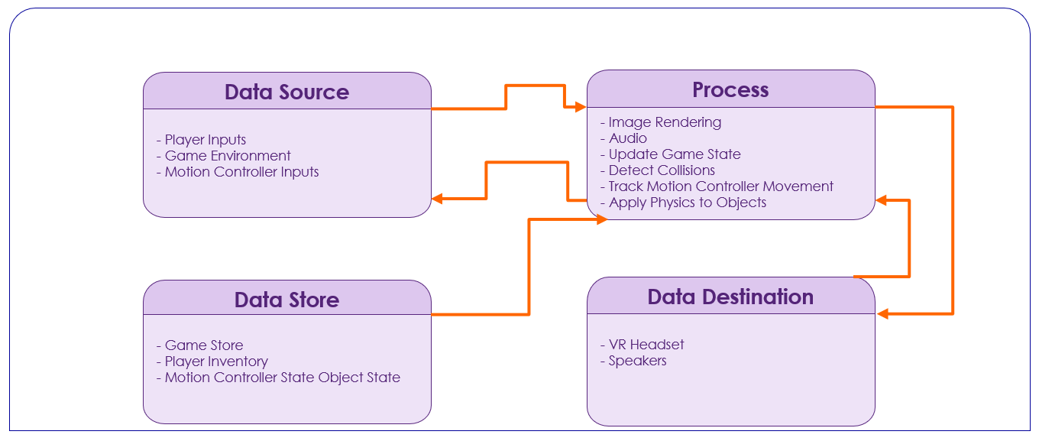

Fig 3.3.1 DFD level 0

The above fig 3.3.1 shows the basic flow of the Game.

In a Level 0 Data Flow Diagram (DFD) of a VR horror game, the central process represents the core gameplay, with data flowing from external sources like VR controllers and databases, through processes such as player interaction and enemy AI, and finally to destinations like rendering visuals and triggering audio effects, all orchestrated to deliver a chilling and immersive gaming experience.

**UML DIAGRAMS**

**Fig 3.3.2 Class Diagram**

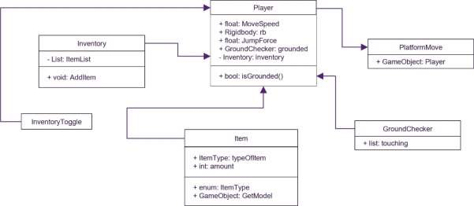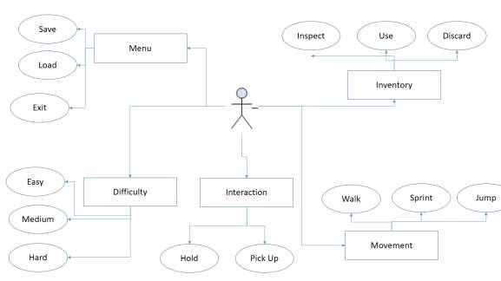

**Fig 3.3.3 Use Case Diagram**

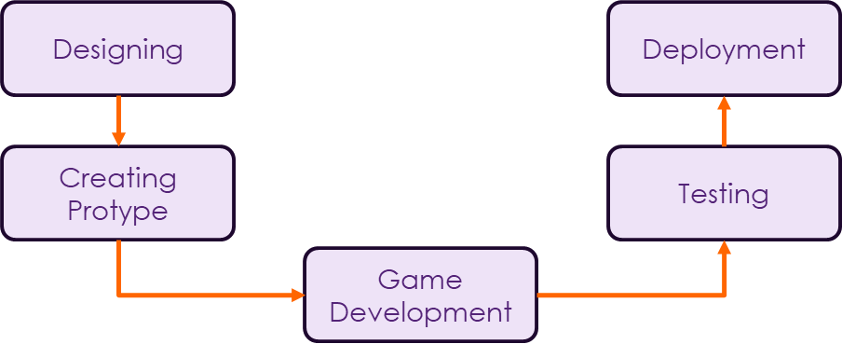

Fig 3.3.4 Basic Flow of the Game

The above fig 3.3.2 shows the basic flow of the application which is shown as a single module.

Right from the User side where they donate through the app, then proceeding towards the rider side where he comes to collect the order and hands it over to the nearest NGO/Shop, which is then distributed to the needy.

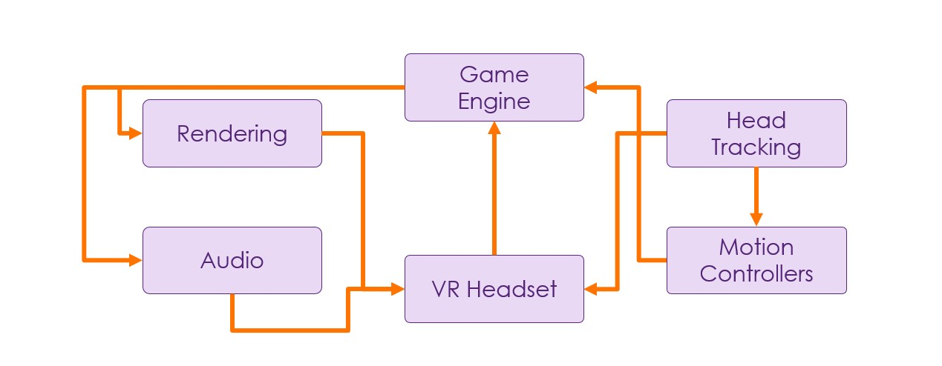

Fig 3.3.5 Architecture of the Game

The above fig 3.3.3 represents the architecture of a VR horror game developed in Unity encompasses a sophisticated integration of various components to deliver a spine-chilling and immersive experience. At its core lies the game engine, Unity, providing a comprehensive development environment for crafting the virtual world and implementing gameplay mechanics. This engine serves as the foundation for integrating essential VR-specific features such as head tracking, motion controllers, rendering, and audio.

The ***VR headset*** acts as the player's gateway to the virtual horror experience, housing display screens, lenses, and sensors to track head movements accurately. Unity interfaces with the headset's SDK to access head tracking data, enabling real-time updates to the in-game camera perspective based on the player's movements. This seamless integration ensures that players can explore the eerie environments from immersive first-person viewpoints.

***Motion controllers*** are pivotal for enabling player interaction within the virtual horror world. Equipped with buttons, triggers, and motion sensors, these controllers facilitate intuitive gestures and movements, allowing players to manipulate objects, interact with the environment, and navigate treacherous scenarios. Unity's support for motion controller integration enables developers to implement immersive and responsive interactions that heighten the horror experience.

***Rendering*** plays a critical role in bringing the terrifying world to life, with Unity's rendering pipeline delivering high-quality graphics, lighting, and visual effects tailored for VR environments. From eerie shadows and atmospheric lighting to intricate textures and immersive environments, Unity's rendering capabilities enable developers to create chilling and visually captivating horror scenes.

***Audio*** serves as the backbone of immersion, enhancing the atmosphere and tension of the VR horror experience. Unity's audio engine allows developers to integrate spatial audio, ambient sounds, and unsettling sound effects that dynamically respond to player actions and environmental cues. This spatial audio simulation ensures that sounds emanate realistically from specific directions, intensifying the sense of dread and suspense. Through the collaborative integration of VR headset functionality, game engine features, head tracking, motion controllers, rendering, and audio, developers can craft a truly terrifying VR horror game that plunges players into a chilling and unforgettable nightmare. This architectural synergy ensures that every element of the experience works harmoniously to immerse players in a world of terror and suspense.

#### Methodology

**1. Conceptualization and Pre-Production:**

• **Idea Generation:** Begin by brainstorming and solidifying the core concept of the VR horror

game, including the setting, storyline, and the specific horror elements to be incorporated.

• **Market Analysis:** Research the VR horror game market to identify trends, audience

preferences, and potential competitors. Use this information to fine-tune your concept.

2. **Technology Selection and Setup:**

• **Game Engine Selection:** Choose a game engine suitable for VR development, such as Unity

or Unreal Engine, and set up the development environment.

• **VR Headset Selection:** Choose the target VR platform and VR headset, considering factors

like the platform's user base and hardware capabilities.

3. **Design and Storytelling:**

• **Narrative Development:** Create a compelling horror storyline and establish the game's world,

characters, and key narrative elements.

**• Environment Design:** Plan and design immersive 3D environments, taking advantage of the

selected game engine's capabilities for rendering.

**4. Art and Audio Asset Creation:**

• **3D Model and Asset Creation:** Develop 3D models, textures, and assets for the game's

characters and environment.

• **Audio Design:** Create a rich soundscape with eerie sound effects, 3D audio, and a haunting

soundtrack to enhance the horror experience.

**5. Game Development:**

**• VR Integration:** Implement VR support within the game engine, ensuring compatibility with

the chosen VR headset and controllers.

**• Rendering:** Optimize the game's graphics and rendering pipeline for VR, considering factors

like frame rate, resolution, and stereoscopic 3D rendering.

**• Head Tracking and Motion Controllers:** Develop head tracking and motion controller

interactions, allowing players to look around and manipulate objects within VR environment.

**6. Testing and Optimization:**

**• VR Comfort Testing:** Test the game for VR comfort and ensure it provides a smooth

experience without causing motion sickness.

**7. Legal Compliance:**

Ensure that the game complies with content ratings, regional regulations, and intellectual

property rights.

#### FLOWCHART:

#### 

#### 

Player interacts with the environment and enemies

GE plays audio based on player's actions

GE renders images based on player's head movement

Motion Controllers track player’s hand movement

VR Headset tracks player’s head movement

Game Engine (GE) Starts

Player puts on VR Headset

GE updates the scene based on player's actions

#### 



Fig 3.3.6 Flowchart

#### 3.4 Implementation Plan:

**Implementation Steps:**

1. **Initialization and Setup:**

* Initialize the game engine and VR hardware (headset and motion controllers).
* Load game assets (3D models, textures, audio files).
* Set up game variables, such as player health and inventory.

2. **Main Game Loop:**

* Continuously update the game world and player's interactions.

3. **Player Movement and Interaction:**

* Track the player's head movement with the VR headset.
* Track the player's hand movements with motion controllers.
* Implement movement controls (e.g., teleportation, physical walking).
* Enable interaction with in-game objects (e.g., grabbing, using items).

4. **Game Environment:**

* Design the virtual environment, including eerie settings and objects.
* Implement lighting and sound effects to create a creepy atmosphere.
* Randomly trigger horror events, such as jump scares or eerie sounds.

5. **AI Entities:**

* Create AI-controlled entities (enemies, NPCs) with behaviour patterns.
* Implement pathfinding and decision-making for enemies.
* Design interactions between AI entities and the player.

6. **Game Logic and Puzzles:**

* Introduce logic puzzles and challenges.
* Define the conditions for puzzle solving and progression.
* Control the flow of the game based on puzzle outcomes.

7. **Audio Management:**

* Play background music to set the mood.
* Trigger specific audio cues in response to player actions and game events.
* Use 3D audio to enhance the spatial perception of sound.

8. **User Interface (UI):**

* Create a VR-friendly user interface, including menus and HUD elements.

9. **End Game:**

* Handle game completion, offering players the option to replay, return to the main menu, or quit the

game.

10. **Cleanup and Resource Release:**

* Release resources and clean up when the game ends or the player quits.

**SYSTEM FLOWCHART:**

**FEATURES:**

**GAME MANAGER:**

In this game, the Game Manager serves as the central controller for managing game state, user interface, resource handling, input, events, scene transitions, game logic, and potentially save/load functionality. It orchestrates these elements to ensure a cohesive and enjoyable player experience.

It manages states of the game; includes Win Condition, Lose Condition and Restart

This defines Game Manager class in Unity, responsible for managing game state transitions and UI elements. It includes methods to display game over and game won screens, as well as restarting the game. The Awake method ensures there's only one GameManager instance using the Singleton

pattern. The Restart method reloads the current scene to restart the game. Overall, it's a basic implementation of a central game management system.

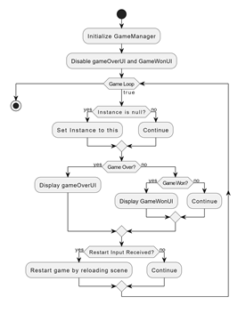

**Fig 3.4.1 Game Manager Flowchart**

**HEAD TRACKING:**

Head tracking in a VR horror game on Android devices involves using the device's built-in sensors, such as gyroscopes and accelerometers, to track the player's head movements. Unity's Android VR integration allows developers to access this tracking data and update the virtual camera's position and orientation accordingly. This ensures that the player's view in the game world aligns with their real-world head movements,enhancing immersion and fear-inducing experiences in virtual reality.

This enables head tracking using the gyroscope sensor on an Android device within a Unity environment. Upon starting, it creates a new GameObject called "Camera Container" to hold the main camera, positioning it at the same location as the script's GameObject. It then sets the script's GameObject as a child of the "Camera Container" to ensure that any rotations applied to the container also affect the camera's orientation.

The script checks if the device supports the gyroscope. If supported, it enables the gyroscope and adjusts the initial rotation of the "Camera Container" to align it correctly with the device's orientation. It then continuously updates the local rotation of the script's GameObject based on the gyroscope's attitude, simulating the player's head movements. Additionally, it ensures that the "Camera Container" follows any positional changes in the virtual environment by updating its position to match that of the CameraSlot Transform.

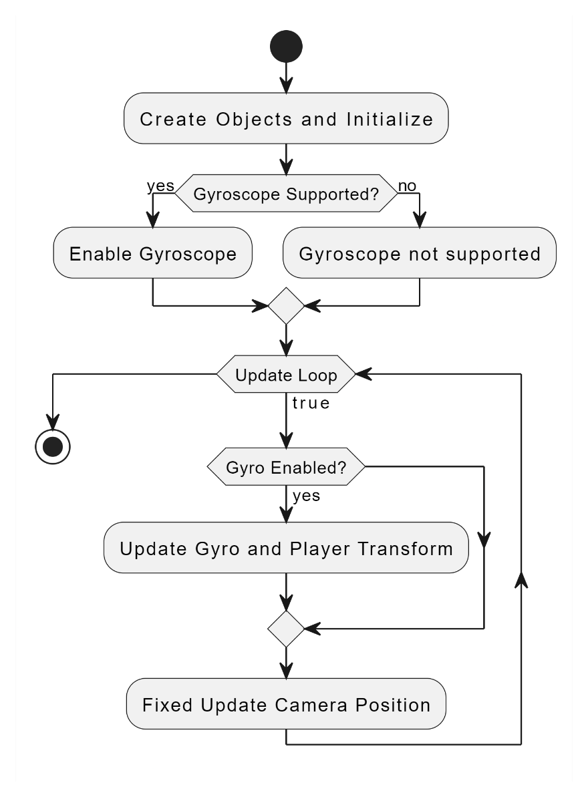

**Fig 3.4.2 Gyroscopic head tracking flowchart**

**ITEM PICKUP:**

In this game, the item pickup mechanism utilizes raycasting to allow players to interact with objects within the virtual environment. When players' cameras, typically representing their viewpoint in VR, look at an object, a raycast is projected from the camera's position in the direction it's facing. If the raycast intersects with an interactable object, indicating that the player is looking at it, they can trigger a pickup action. This action might involve pressing a button on their VR controller to pick up the object. Implementing item pickup via raycasting provides a natural and intuitive way for players to interact with objects in the game world, enhancing immersion and gameplay in the VR horror experience.

In a VR horror game developed in Unity, item pickup mechanics involve players using VR controllers to interact with objects in the virtual environment. Players can typically grab items by pressing buttons on their controllers, and once picked up, they can manipulate and use these items to progress through the game. Visual and auditory cues provide feedback to players when they successfully pick up an item, enhancing immersion. Item pickup mechanics often play a crucial role in solving puzzles, unlocking doors, and uncovering secrets, adding depth to the gameplay and driving the narrative forward.

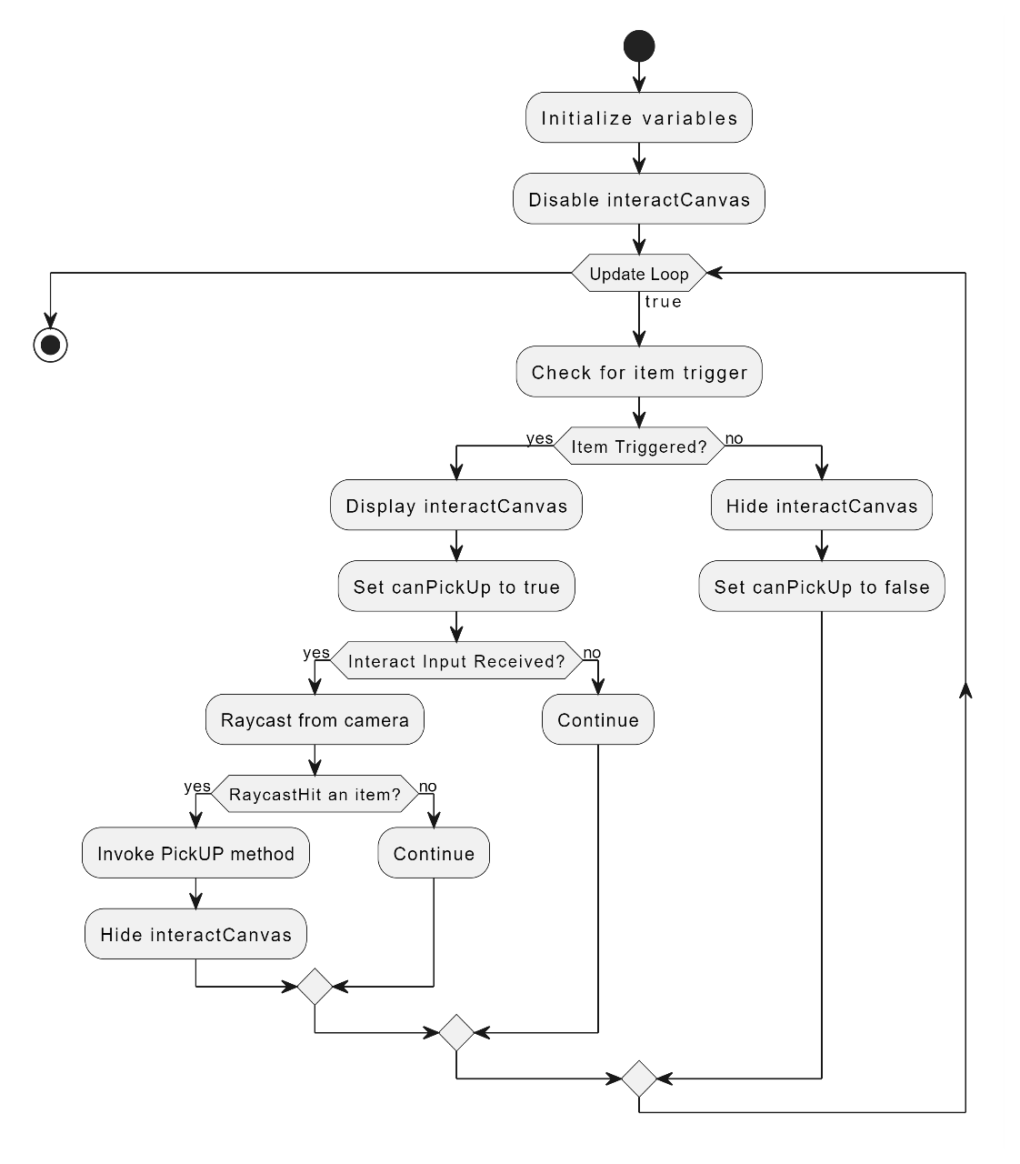

**Fig 3.4.3 Mechanism to Pick Up items**

**ITEM SPAWNER:**

In this game, implementing an Item Spawner is crucial for enhancing player immersion and progression. The flowchart begins with initialization, setting up variables and parameters related to item spawning. As the game starts, triggers activate the spawning process based on player progress and game state. The spawner evaluates conditions such as player proximity and visibility to determine when and where to spawn items. Once triggered, the spawner selects items and places them strategically within the game world, incorporating animations and audio cues to alert players. Players can then interact with these items using their VR controllers, aiding progression by solving puzzles or unlocking new areas. Throughout the game, the spawner continually evaluates player actions and adjusts spawning accordingly, ensuring a dynamic and immersive experience. By following this flowchart, developers can create a compelling VR horror game where item spawns contribute to the atmosphere, challenge, and narrative progression, keeping players engaged and immersed in the experience**.**

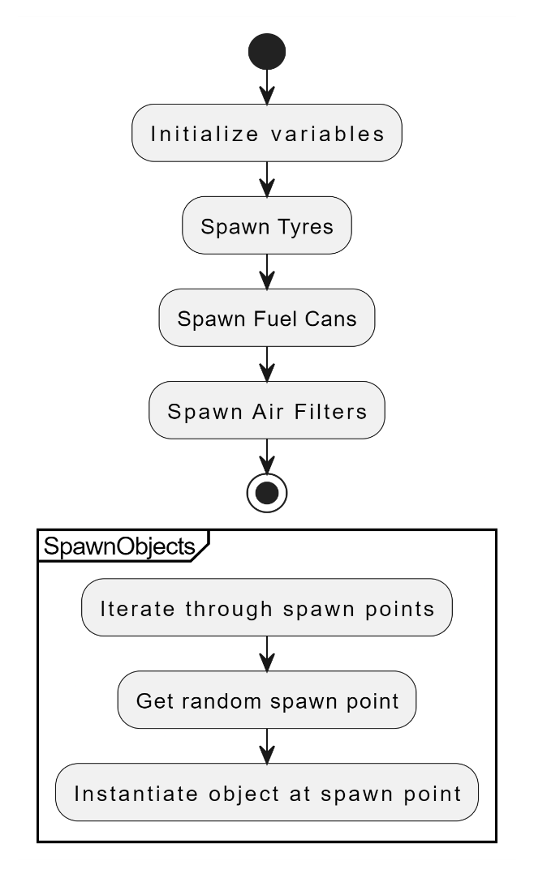

**Fig 3.4.4 Item Spawner Flowchart**

**AI ENEMY:**

The enemy movement in a VR horror game is governed by several states that dictate the behavior of the enemy AI. These states include "Idle," "Patrol," "Chase," and "Attack." During the "Idle" state, the enemy remains stationary or follows predefined patrol routes within the game world. Upon detecting the player within the "Chase" range, the enemy transitions into the "Chase" state, where it actively pursues the player's last known position. In the "Patrol" state, the enemy roams the environment according to a set patrol radius, periodically reducing its patrol area over time. If the player enters the enemy's "Close Range" zone, the enemy switches to the "Attack" state, triggering an attack animation to grab the player. The script utilizes a NavMeshAgent component to navigate the enemy AI, allowing it to move smoothly within the game environment. Through these states, the "EnemyController" script creates dynamic and immersive encounters, enhancing the player's sense of tension and fear in the VR horror experience.

In a VR horror game developed in Unity, managing enemy movement involves defining various states that dictate how enemies behave and interact with the player. These states include idle, patrol, alerted, chase, attack, and return to patrol. During the idle state, enemies remain stationary or follow predetermined patrol routes, establishing a baseline behavior when they are not actively engaged with the player. When alerted to the player's presence, enemies transition into an alerted state, prompting them to investigate or search for the player. Upon detecting the player, enemies enter a chase state, where they actively pursue the player, increasing tension and urgency. In the attack state, enemies engage the player with offensive actions such as melee or ranged attacks, posing a direct threat. Once the player evades detection or escapes combat, enemies may return to their patrol routes or idle behavior, creating dynamic and unpredictable encounters. Implementing these enemy states in a VR horror game adds depth to gameplay, enhancing immersion and providing players with challenging and suspenseful experiences.

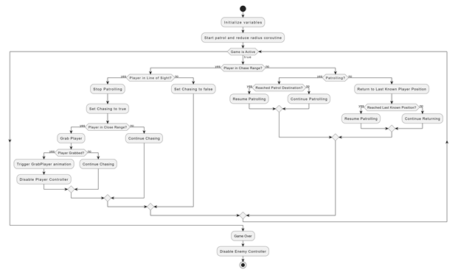

**Fig 3.4.5 Enemy movement flowchart**

**ENEMY COLLIDER:**

In a VR horror game, implementing enemy collider functionality is essential for enabling interactions between the player and enemy entities. The enemy collider implementation involves attaching colliders to the enemy AI's game objects, typically encompassing their physical boundaries. These colliders are configured to detect collisions with other game objects, including the player character's collider. When the player enters the detection range of the enemy collider, it triggers specific actions or state transitions within the enemy AI's behavior. For example, when the player comes into contact with the enemy collider, it may initiate a chase sequence, causing the enemy to pursue the player. Additionally, the enemy collider can detect when the player is within attack range, prompting the enemy to perform attack animations or actions. Through careful tuning of collider properties such as size, shape, and detection range, developers can create immersive and responsive enemy interactions that contribute to the tension and suspense of the VR horror experience. Moreover, efficient collision detection algorithms and optimizations are crucial to maintaining smooth gameplay performance, especially in dynamic and fast-paced scenarios typical of VR horror games.

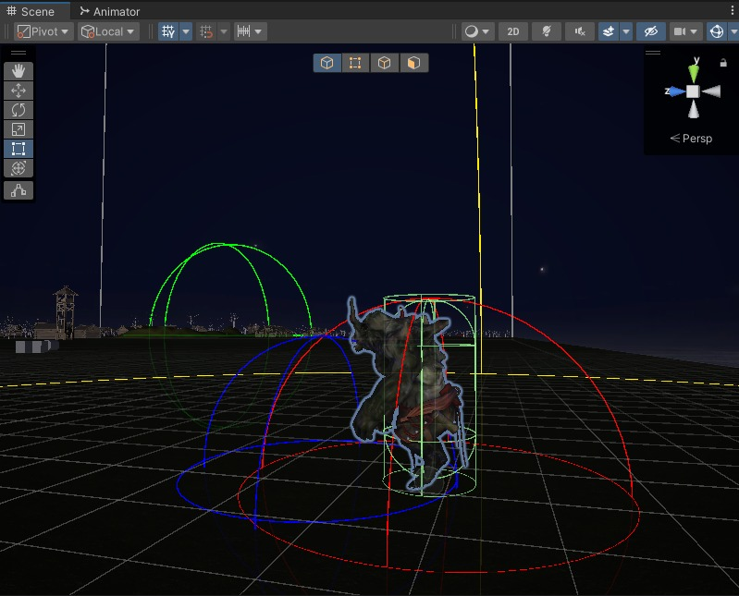

**Fig 3.4.6 Enemy Collider Implementation**

**GAME MAP:**

In a VR horror game featuring a tire spawn point, the game map includes specific locations where tires are dynamically generated or placed within the virtual environment. These tire spawn points serve multiple purposes, such as enhancing the atmosphere, providing interactive elements, and contributing to gameplay mechanics. The placement of tire spawn points within the game map is strategic, often positioned in areas that amplify the sense of tension, isolation, or danger for players. For example, tires might be scattered around abandoned vehicles, dark alleyways, or dilapidated structures, adding to the overall sense of desolation and foreboding. From a gameplay perspective, players may need to interact with these tires to solve puzzles, unlock pathways, or evade enemies, making their placement and distribution crucial to the game's progression and challenges. Overall, the inclusion of tire spawn points in the game map of a VR horror game adds depth, immersion, and interactivity to the player experience, while also contributing to the eerie atmosphere and narrative ambiance of the virtual world.

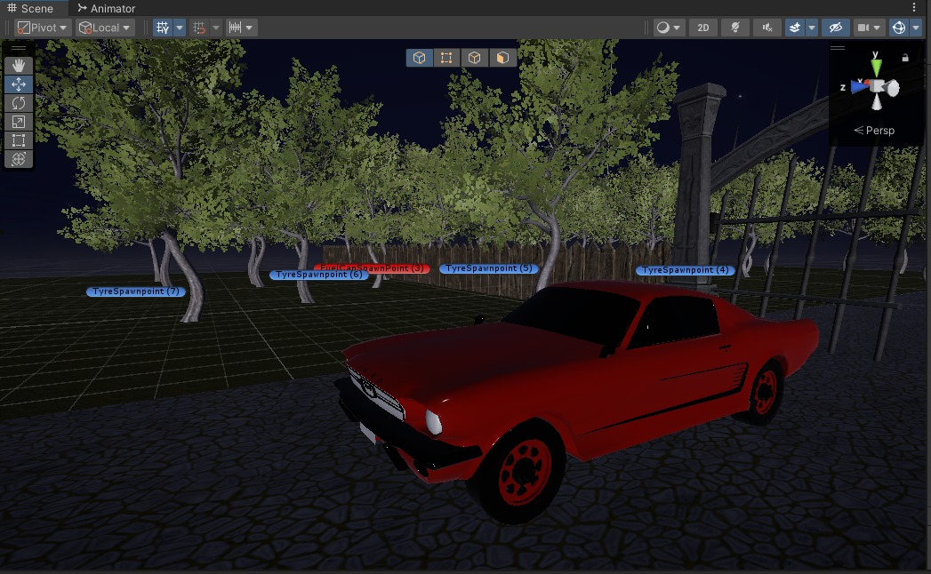

**Fig 3.4.7 Game Map**

## **4. Test Cases**

Table 4.1 Test Cases

|  |  |  |  |  |
| --- | --- | --- | --- | --- |
| Sr No. | Name | Input | Output | Type |
| 1 | Environment and Navigation | Gamepad Controller and Gyroscope | The player can navigate through the virtual environment and interact with objects in the environment using VR controllers. | Functionality |
| 2 | Gameplay Mechanics | Interactive Objects, Pickable Objects, Enemy, Repairable Objects, Movement | Gameplay mechanics such as puzzle-solving, hiding from enemies. | Functionality |
| 3 | Visual and Audio Effects | Textures, Materials, Lighting, Footsteps Sound, Environmental Sounds, Enemy Audio clips | Visual effects create the intended atmosphere for a horror experience. | Functionality |
| 4 | User Interface and Controls | Inventory Panel, Captions, Health Bar, Journal | Ensure that the user interface elements are clear and readable in VR. | User  Interface |
| 5 | Compatibility and Integration | Android Devices, Windows | Test compatibility with different input devices to ensure consistent functionality across platforms | Usability Test |

## **5. Results & Discussion**

The result of a VR horror game built on Unity is an immersive and terrifying experience that

transports players into horrifying virtual environments. Players navigate through eerie landscapes,

encounter chilling creatures, and solve puzzles while experiencing intense suspense and fear. The

game leverages Unity's powerful graphics capabilities and C# scripting to deliver realistic visuals,

immersive audio, and responsive gameplay. With intuitive VR controls and carefully crafted scares,

players are kept on the edge of their seats, providing an unforgettable horror gaming experience in

virtual reality.

Top of Form

Top of Form

Frontend

The frontend of a VR horror game in Unity using C# focuses on creating an immersive experience through terrifying environments, minimalistic UI elements integrated into the game world, and realistic character models. Interaction is facilitated via VR controllers, triggering responses through C# scripts. Spatial audio design adds to the realism, with sounds positioned to enhance immersion. The design prioritizes smooth UX, optimizing frame rates and minimizing discomfort. Overall, it aims to deliver a spine-chilling experience that keeps players engaged and scared in virtual reality.

## **6. Conclusion and Future Scope**

In conclusion, developing an immersive first-person view (FPV) virtual reality (VR) horror game is both challenging and rewarding. This genre has the potential to offer players a spine-tingling and unforgettable experience. Attention to every detail, from the chilling narrative and atmospheric environments to realistic character models and haunting audio, is crucial. By harnessing the capabilities of game engines, VR headsets, rendering techniques, and motion controllers, developers can craft a world where players feel fully immersed and utterly vulnerable. The success of a VR horror game hinges on its ability to terrify and captivate players, compelling them to explore, solve puzzles, and survive in a nightmarish realm. Iterative testing, user feedback, and continuous improvement are essential throughout the development process. Ultimately, a successful VR horror game creates an experience that lingers long after the headset is removed, leaving players with a sense of true immersion and the haunting thrill of a virtual world well-executed. Whether you're a seasoned horror enthusiast or a newcomer to the genre, our VR Horror Game promises an unforgettable journey into the heart of fear.

Incorporating diverse and culturally rich storytelling into VR horror games enhances their appeal, attracting a broader audience by providing unique perspectives and experiences. Collaborating with local talent, artists, and storytellers adds authenticity and originality to the game, elevating its overall quality and immersing players in rich, culturally diverse narratives. Additionally, expanding into multiplayer VR horror experiences fosters a social gaming aspect, allowing players to share fear and excitement, enhancing immersion and creating memorable shared experiences.

Top of Form

**References**

1. Ntokos, Konstantinos. "Level of fear”: Analysis of fear spectrum into a tool to support horror game

design for immersion and fear." An International Journal (CGDEIJ) 1, no. 33-43 (2018).

1. Årnell, Tobias, and Nikola Stojanovic. "Horror game design–what instills fear in the player?: A

study on the effects of horror game design theories and level design patterns on player behaviour in a

horror environment." (2020).

1. Ziwen. "Analysis of the design aesthetics and player emotions of horror games: Take ‘Little

Nightmares’ as a case." (2022).

1. de Lima, Edirlei Soares, Bruno MC Silva, and Gabriel Teixeira Galam. "Adaptive virtual reality

horror games based on Machine learning and player modeling." Entertainment

Computing 43 (2022): 100515.

1. Shaikh, Omar, Yilu Sun, and Andrea Stevenson Won. "Movement visualizer for networked virtual

reality platforms." *2018 IEEE Conference on Virtual Reality and 3D User Interfaces (VR)*. IEEE,

2018.

1. Lin, Jih-Hsuan Tammy, Dai-Yun Wu, and Chen-Chao Tao. "So scary, yet so fun: The role of

self-efficacy in enjoyment of a virtual reality horror game." New Media & Society 20.9 (2018):

3223-3242.

1. Lin, Tammy Jin-Hsuan. "Virtual Reality Horror Games and Fear in Gaming." *Oxford*

*Research Encyclopedia of Communication*. 2023.

1. Bian, Shijie. "Research on the Application of VR in Games." *Highlights in Science, Engineering*

*and Technology* 39 (2023): 389-394.

1. Zhang, Ruiqi. "Research on the Progress of VR in Game." *Highlights in Science, Engineering*

*and Technology* 39 (2023): 103-110.